1. 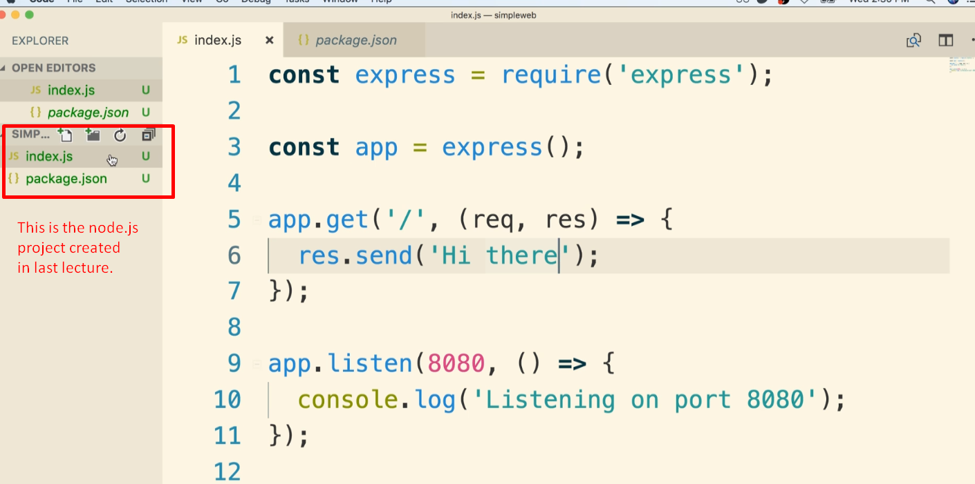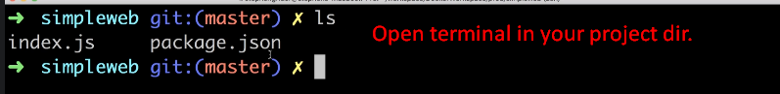
2. OK, so we have got some source code and we have to wrap all that inside a Docker Container.
3. Let me tell you first how we’re going to start a node.js app inside a container. 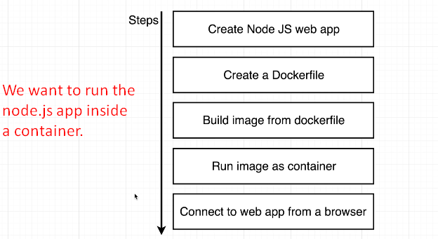
4. You need to know about two commands. One to install the dependencies and 2nd to start the app.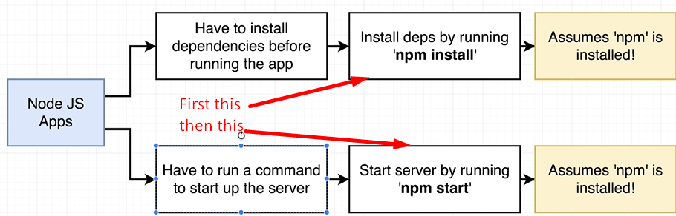
5. 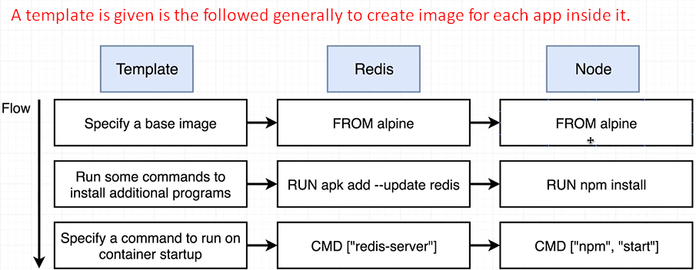
6. 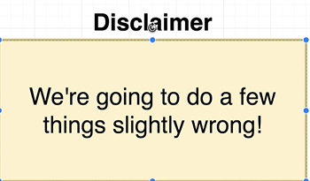
7. 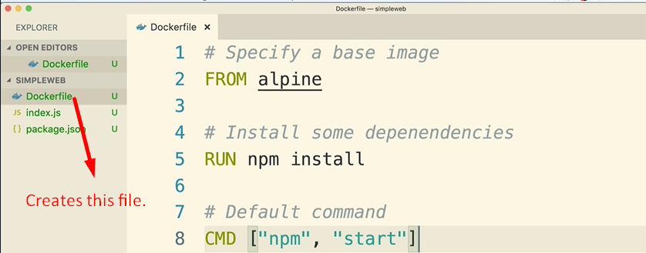
8. 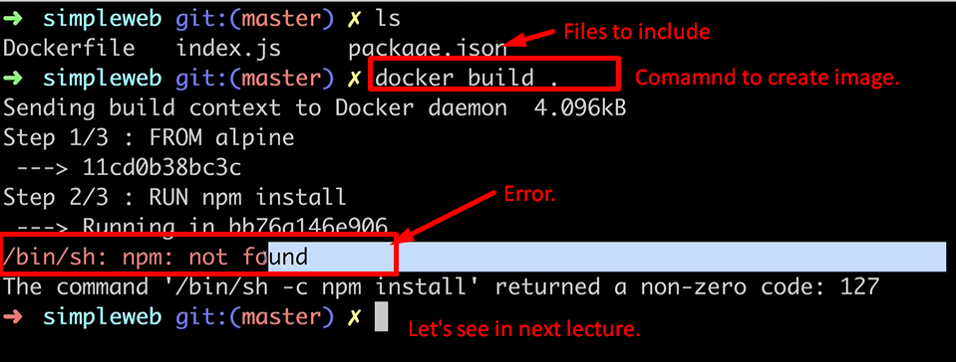
9. docker build . 🡺 dot is the **build context**.